Homework

FIU Spring 2017

Course ID:

ESI 6455 Advanced Engineering Project Management

Instructor: Dr. Chin-Sheng Chen

Chapter: 13 P490 E6

Student Name: Ziying Zheng (6039887)

E-mail: zhengziying77@gmail.com

Q6:

After 6 time periods the project is roughly 66% complete and so far, work on the project has taken 1600 hours less work than planned. There is 400 hours’ worth of work on Activity 4 which was supposed to have been done that has not done. Snice Activity 4 is on the critical path, the project is behind scheduled. If scheduled is the number priority, the project manager may want to consider investing some of the savings on accelerating critical activities.

|  |  |  |  |  |  |  |  |  |  |  |  |  |  |  |  |  |  |  |  |  |  |
| --- | --- | --- | --- | --- | --- | --- | --- | --- | --- | --- | --- | --- | --- | --- | --- | --- | --- | --- | --- | --- | --- |
|  |  |  |  |  |  | 2 | 2 | 4 |  |  |  | 4 | 5 | 8 |  |  |  |  |  |  |  |
|  |  |  |  |  |  | 3 |  | 3 |  |  |  | 3 |  | 3 |  |  |  |  |  |  |  |
|  |  |  |  |  |  | 5 | 2 | 7 |  |  |  | 7 | 4 | 11 |  |  |  |  |  |  |  |
|  |  |  |  |  |  |  |  |  |  |  |  |  |  |  |  |  |  |  |  |  |  |
| 0 | 1 | 2 |  |  |  | 2 | 3 | 8 |  |  |  |  |  |  |  |  |  | 11 | 7 | 13 |  |
| 0 |  | 0 |  |  |  | 3 |  | 3 |  |  |  |  |  |  |  |  |  | 0 |  | 0 |  |
| 0 | 2 | 2 |  |  |  | 5 | 6 | 11 |  |  |  |  |  |  |  |  |  | 11 | 2 | 13 |  |
|  |  |  |  |  |  |  |  |  |  |  |  |  |  |  |  |  |  |  |  |  |  |
|  |  |  |  |  |  | 2 | 4 | 7 |  |  |  | 7 | 6 | 11 |  |  |  |  | LEGEND | | |
|  |  |  |  |  |  | 0 |  | 0 |  |  |  | 0 |  | 0 |  |  |  |  | ES | ID | EF |
|  |  |  |  |  |  | 2 | 5 | 7 |  |  |  | 7 | 4 | 11 |  |  |  |  | SL |  | SL |
|  |  |  |  |  |  |  |  |  |  |  |  |  |  |  |  |  |  |  | LS | DUR | LF |

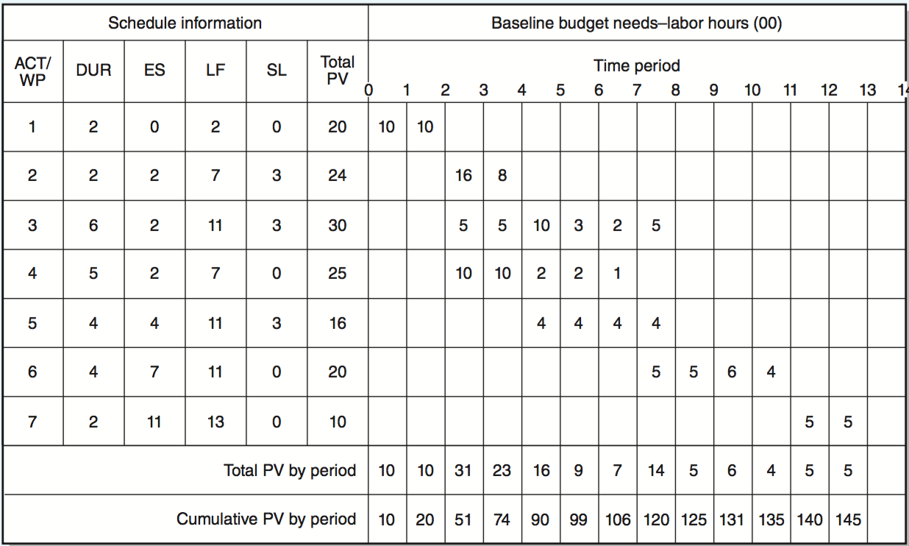

Status Report: Ending Period 1

|  |  |  |  |  |  |  |
| --- | --- | --- | --- | --- | --- | --- |
| Task | Complete% | EV | AC | PV | CV | SV |
| 1 | 50% | 1000 | 500 | 1000 | +500 | 0 |
| Cumulative Totals | | 1000 | 500 | 1000 | +500 | 0 |

Status Report: Ending Period 2

|  |  |  |  |  |  |  |
| --- | --- | --- | --- | --- | --- | --- |
| Task | Complete% | EV | AC | PV | CV | SV |
| 1 | Finished | 2000 | 1500 | 2000 | +500 | 0 |
| Cumulative Totals | | 2000 | 1500 | 2000 | +500 | 0 |

Status Report: Ending Period 3

|  |  |  |  |  |  |  |
| --- | --- | --- | --- | --- | --- | --- |
| Task | Complete% | EV | AC | PV | CV | SV |
| 1 | Finished | 2000 | 1500 | 2000 | +500 | 0 |
| 2 | 0% | 0 | 0 | 1600 | 0 | -1600 |
| 3 | 10% | 300 | 200 | 500 | +100 | -200 |
| 4 | 20% | 500 | 500 | 1000 | 0 | -500 |
| Cumulative Totals | | 2800 | 2200 | 5100 | +600 | -2300 |

Status Report: Ending Period 4

|  |  |  |  |  |  |  |
| --- | --- | --- | --- | --- | --- | --- |
| Task | Complete% | EV | AC | PV | CV | SV |
| 1 | Finished | 2000 | 1500 | 2000 | +500 | 0 |
| 2 | 50% | 1200 | 1000 | 2400 | +200 | -1200 |
| 3 | 30% | 900 | 800 | 1000 | +100 | -100 |
| 4 | 40% | 1000 | 1500 | 2000 | -500 | -1000 |
| Cumulative Totals | | 5100 | 4800 | 7400 | -300 | -2300 |

Status Report: Ending Period 5

|  |  |  |  |  |  |  |
| --- | --- | --- | --- | --- | --- | --- |
| Task | Complete% | EV | AC | PV | CV | SV |
| 1 | Finished | 2000 | 1500 | 2000 | +500 | 0 |
| 2 | Finished | 2400 | 2000 | 2400 | +400 | 0 |
| 3 | 50% | 1500 | 800 | 2000 | +700 | -500 |
| 4 | 60% | 1500 | 1500 | 2200 | 0 | -700 |
| 5 | 25% | 400 | 400 | 400 | 0 | 0 |
| Cumulative Totals | | 7800 | 6200 | 9000 | +1600 | -1200 |

Status Report: Ending Period 6

|  |  |  |  |  |  |  |
| --- | --- | --- | --- | --- | --- | --- |
| Task | Complete% | EV | AC | PV | CV | SV |
| 1 | Finished | 2000 | 1500 | 2000 | +500 | 0 |
| 2 | Finished | 2400 | 2000 | 2400 | +400 | 0 |
| 3 | 80% | 2400 | 2100 | 2300 | +300 | +100 |
| 4 | 80% | 2000 | 1800 | 2400 | +200 | -400 |
| 5 | 50% | 800 | 600 | 800 | +200 | 0 |
| Cumulative Totals | | 9600 | 8000 | 9900 | +1600 | -300 |

Indexes

|  |  |  |  |  |
| --- | --- | --- | --- | --- |
| Period | SPI | CPI | PCIB |  |
| 1 | 1.00 | 2.00 | 0.07 |  |
| 2 | 1.00 | 1.33 | 0.14 | SPI=EV/PV |
| 3 | 0.55 | 1.27 | 0.19 | CPI=EV/AC |
| 4 | 0.69 | 1.06 | 0.35 | PCIB=EV/BAC |
| 5 | 0.87 | 1.26 | 0.54 |  |
| 6 | 0.96 | 1.20 | 0.66 |  |

CPI=1.20

SPI=0.96

PCIB=0.66